Timeline of President Clinton

Essential Question: How can we interpret and represent data using the events of President Clinton’s life to date?

Objective: Calculate elapsed time using a timeline.

Standard:

4.MD.A.2 Use the four operations to solve word problems involving distances, intervals of time, liquid volumes, masses of objects, and money, including problems involving simple fractions or decimals, and problems that require expressing measurements given in a larger unit in terms of a smaller unit.

Description/Activity:

1. Teacher introduces lesson. Introduce timeline concept using the following [website](http://softschools.com/timelines/bill_clinton_timeline/205/) on President Clinton.
2. Give example of an elapsed time from the timeline.
3. Put students in pairs.
4. Model creating a question and answer and then discuss the assignment. See example questions (feel free to create others)
   1. How much time elapsed between when President Clinton became Governor and then President?
   2. How old was President Clinton when he became Governor of Arkansas?
   3. How old was President Clinton when he became President of the United States?
5. In pairs, students create at least three math questions using the timeline.
6. Collect student’s questions and redistribute to other pairs and then allow students to answer math problems.
7. If time allows, have students share their answers.

Grade: 4th grade

Subject: Math and Science

Time: 60 minutes Photo: Hervey House

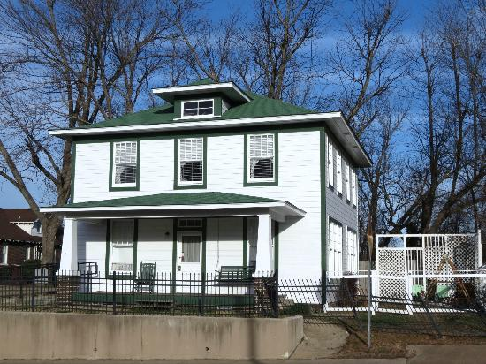

Feature description: Using the yearly timeline of President Clinton’s accomplishments, students will generate math problems using addition, subtraction and multiplication for other classmates to solve.

Standards: 4.MD.A.2